<header same as website (no menu) >

<Title of Blog - using same blue colour used in logo – bold text>

Dear <FIRST NAME>,

I want to share our latest Stock Market Analysis for <CATEGORY – e.g GOLD, CURRENCY etc), here the video below:

<put the youtube video>

<below the youtube video, same like the image below, show only the first 300 characters of the blog TEXT>
<put READ MORE with hyperlink the the blog post URL at the end of the 300 characters text>
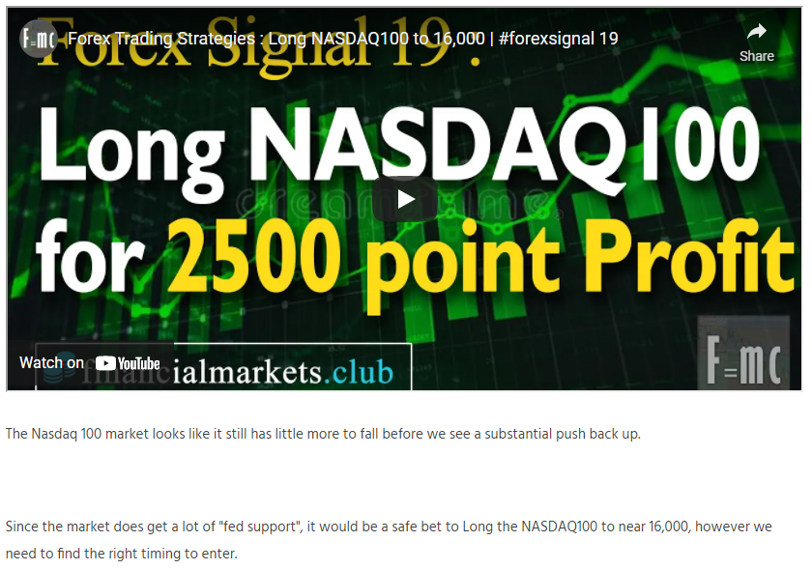

I hope this will help you with your Stock Market Trading.

Thanks for keeping in touch, I look forward to our next Analysis and see lots of Profits on your Trading!

Best Regards

FINANCIAL MARKETS CLUB

<put a light grey box on the text below so reader can focus on this. make sure give some padding to make it look good>
Remember you have these options below to help you with your Trading:

- FOLLOW me Forex Trades as they happen on my forex trading Telegram Channel for instant updates on my Forex Signals:
https://t.me/goldium_forex_signals

- JOIN my exclusive Premium Forex Signal Service for only $1 per day to see exactly what I am trading on the forex market and when I am trading:
www.financialmarkets.club

- Need help making Profits? Not sure why you keep losing on your Trades? Book a 1-2-1 Session with me, and I will review your Trading, and discuss How to Improve your Trading with you:
www.financialmarkets.club

